**Journal Report 16**

**12/15/23**

I spent the majority of the class, setting up an environment and preparing my data. The time series I will be using to create a baseline model looks like this:

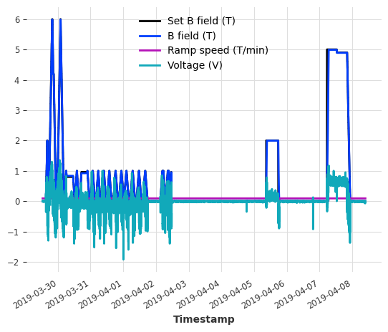

I took out many variables and am planning to take out Ramp speed and Voltage in order to train a barebones model.

**Winter Break**

During my winter break, my one goal was to train a forecasting model on one time series.First, I preprocessed my dataset by taking out all variables except for the Set B field and B field as I wanted to make sure that my baseline model was learning the pattern that the B field should follow and be a little above or below the Set B field. In order to do this, I had to have something called a future covariate, which is a time series whose future values are known at prediction time. In my case, this was the Set B field as this setpoint should always be known throughout the handling of the CCR and throughout the neutron beam experiment. I chose the RNN model as my base because it was the easiest to implement on univariate data and didn’t require any special hyperparameter tuning. The model parameters is shown here:

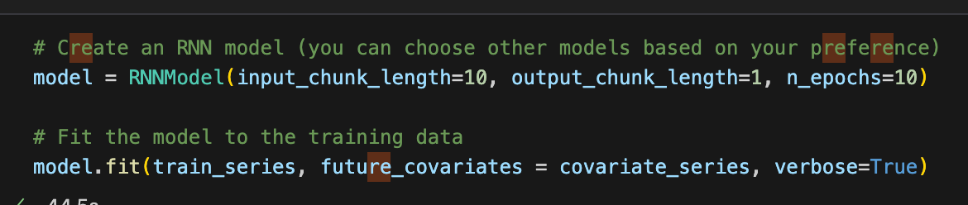

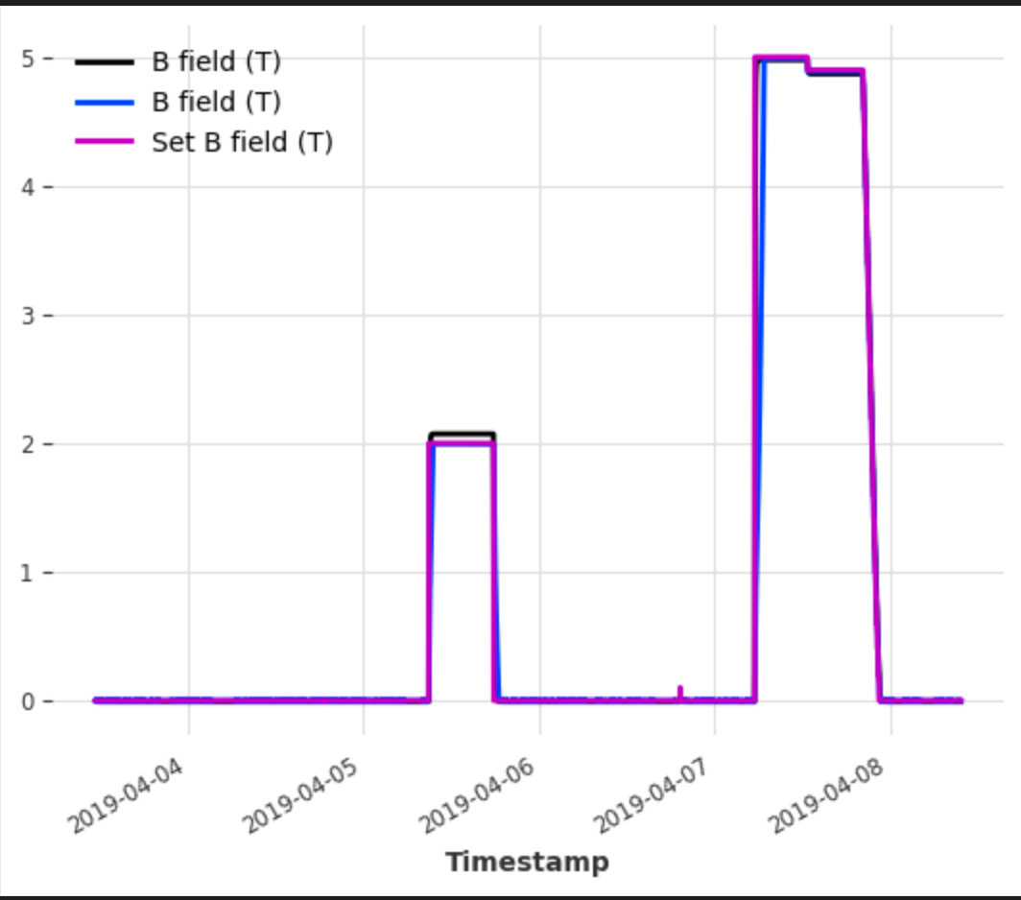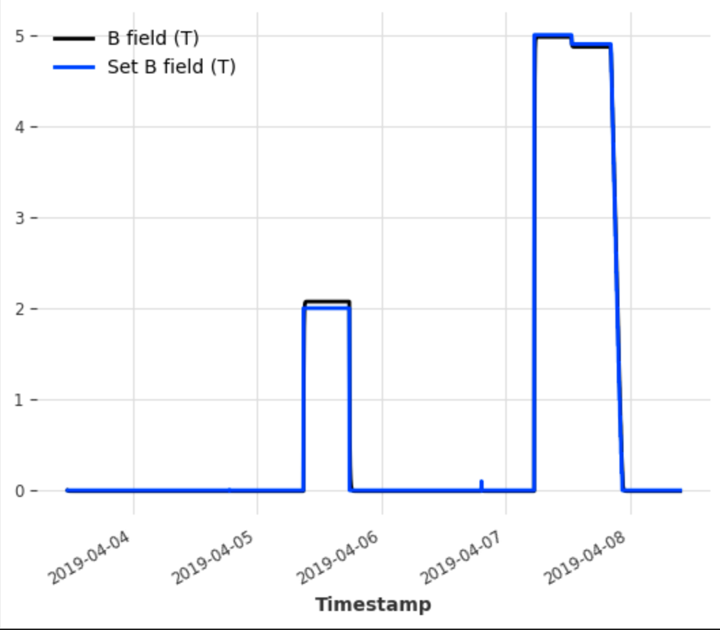

The RNN overestimates a bit, but overall the RNN model preserves the trend that the B field follows the Set B field. The two metrics that I will be using for model performance comparisons are shown below for this model:

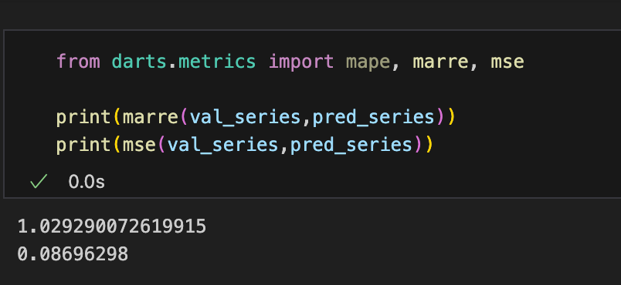

Afterwards, in order to see how it reacts to other variables, I researched past covariates. Past covariates are covariates known only into the past. In my case, these include Ramp speed. I am thinking about forecasting voltage in conjunction with the B field because it would be useful to see how the model changes in relation to the noisy voltage signals.

I spent the rest of my break preparing my data into three sections: forecasting data, past covariates, future covariates.

**01/03/24**

I was absent from school on this day, but I managed to train a model with a future covariate that consisted of the Set B field and all other variables as a target variable, or a variable that is forecasted. I found that setting the Set B field as the future covariate is the right choice and the new model performs fairly well, but it doesn’t seem to preserve the noise from the voltage when forecasting as shown below.

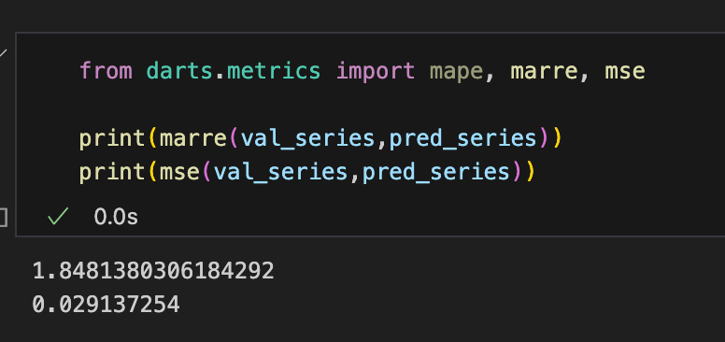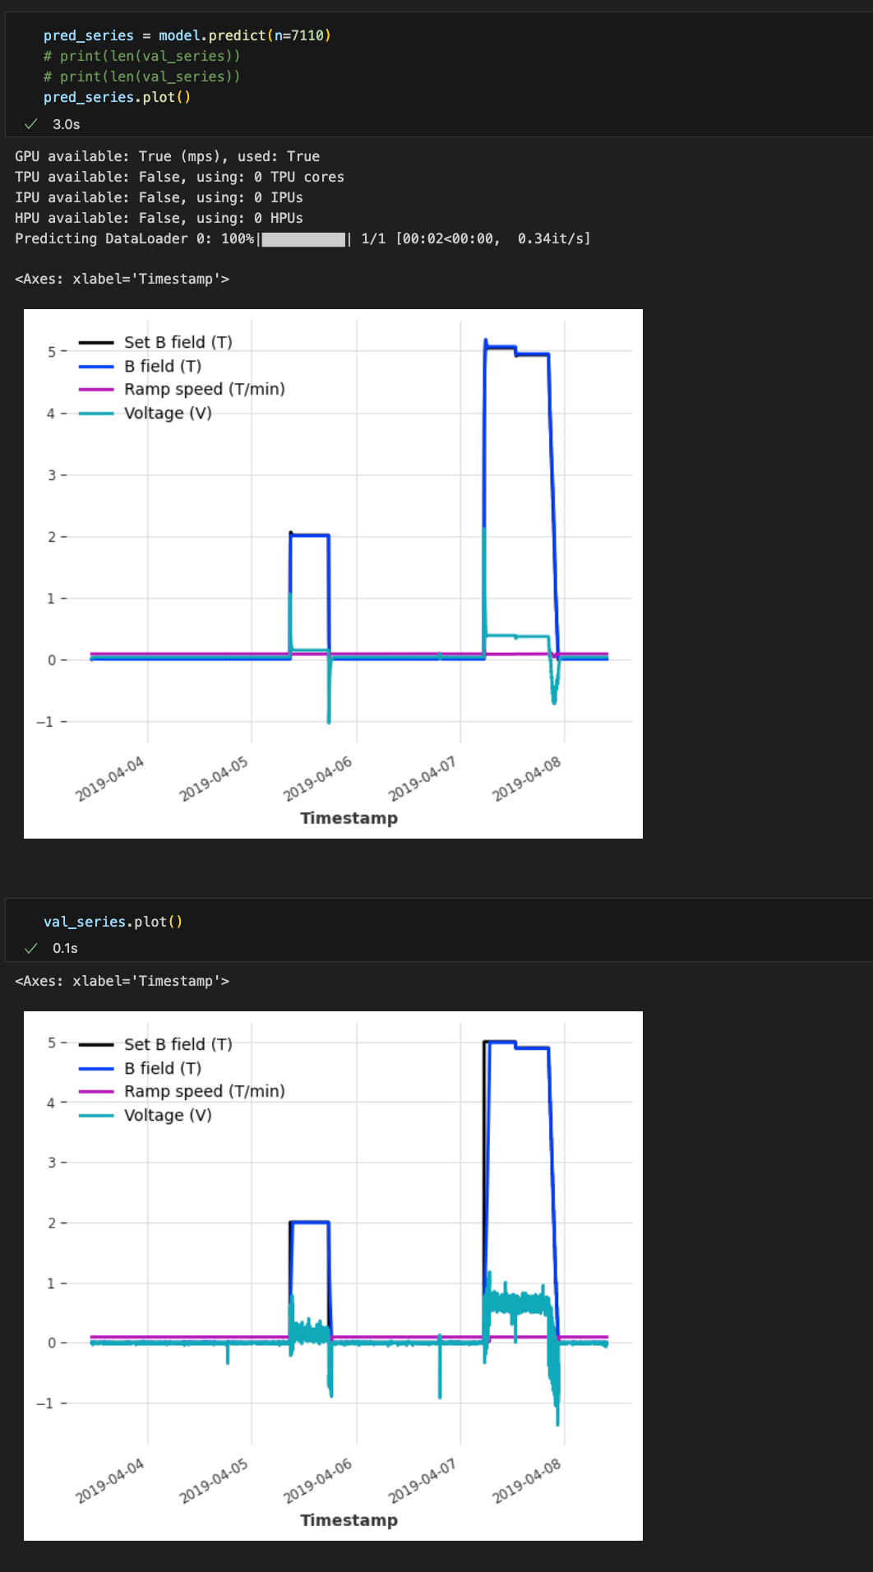

I am now researching if introducing the other variables as past covariates may help. Rnn doesn’t support past covariates so I have to use a different model. I will try to implement this by Monday.